PROBLEM DEFINITION

1.1 BACKGROUND OF THE STUDY

The Family Income and Expenditure Survey (FIES) is a survey undertaken every three years across all the regions in the Philippines by the Philippine Statistics Authority (PSA). This survey aims at gathering information on income, expenditure, and general economic situation of families. FIES data set for 2015 includes data from 41,544 households across 17 regions, containing information on a wide variety of variables like household income, expenditure details, housing situation and other demographic information.

Despite the wealth of FIES data that are available, previous works concentrate mainly on determining regional averages of incomes and graphing expenditures. Such an approach addresses the matter of how much people spend, but fails to answer another more important issue from a computational point of view, namely the speed at which expenditures rise with respect to income and when does this acceleration begin. This concern is especially important for basic expenditures like food, education, and healthcare expenses because a rapid rise in expenditures may indicate distress in the economy.

This study fills that gap by using numerical differentiation and numerical integration methods, such as the Central Difference Formula and the Trapezoidal Rule, to measure the rate and extent of changes in household expenditures in different income levels and geographic locations within the Philippines.

1.2 PROBLEM STATEMENTS

The core problem this study addresses is the lack of quantitative, computationally derived indicators that measure the rate of change and cumulative burden of essential household expenditures across income brackets and regions in the Philippines using the 2015 PSA FIES dataset.
Specifically, the study seeks to answer the following technical questions:
- How can the Central Difference Formula be implemented to compute the rate of change of household expenditures (food, education, and medical care) across income brackets per region?
- How can the Trapezoidal Rule be applied to calculate the cumulative expenditure burden accumulated across all income levels within each region?
- Which Philippine regions exhibit the highest acceleration in essential expenditures, and at which income bracket does that acceleration peak?
- How do expenditure rate patterns compare across all 17 regions to surface regional disparities in spending behavior?

1.3 OBJECTIVES
This study aims to:
- Apply the Central Difference Formula to compute the rate of change of household expenditures (food, education, and medical care) across income brackets per region.
- Apply the Trapezoidal Rule to calculate the cumulative expenditure burden accumulated across all income levels within each region.
- Identify which Philippine regions exhibit the highest acceleration in essential expenditures, and at which income bracket that acceleration peaks.
- Compare expenditure rate patterns across all 17 regions to surface regional disparities in spending behavior.

1.4 SIGNIFICANCE OF THE STUDY
This study is significant to several sectors and disciplines.

Government Agencies
Government institutions such as the Department of Social Welfare and Development (DSWD), National Economic and Development Authority (NEDA), and local government units may use the findings to identify regions experiencing increasing expenditure pressure. The results can support subsidy allocation, healthcare planning, and educational assistance programs.

Academic Community
The study contributes to the field of Computer Science by demonstrating the practical application of numerical methods, data analytics, and computational modeling to real-world socioeconomic datasets.

Future Researchers
The study establishes a reproducible computational workflow that may be extended to future FIES datasets or adapted to other large-scale economic datasets.

Students and Developers
The project serves as a reference for students and developers interested in data science, computational science, numerical analysis, and socioeconomic modeling.

MATHEMATICAL AND COMPUTATIONAL MODEL

2.1 Overview
This study models household expenditure as a continuous function of income, where income brackets serve as discrete points along the x-axis and the average expenditure per bracket serves as the corresponding function value. Two numerical methods from Computational Science are applied: the Central Difference Formula to measure how fast expenditure changes as income rises, and the Trapezoidal Rule to measure the total expenditure burden accumulated across all income levels. Three expenditure categories are used as the primary variables of analysis: Total Food Expenditure, Education Expenditure, and Medical Care Expenditure — chosen because they represent essential, non-negotiable spending that most directly reflects a household's economic condition.

2.2 Data Preparation
The 41,544 household records from the 2015 Philippine Statistics Authority (PSA) Family Income and Expenditure Survey (FIES) are grouped into eight income brackets and further subdivided by region. For each bracket, the average expenditure per category is computed. This produces a discrete set of data points that approximates a continuous expenditure function. The eight income brackets and their corresponding national average expenditure values are presented in Table 1.

Table 1. National Average Expenditure per Income Bracket (2015 PSA FIES, n = 41,544)
Income Bracket | Midpoint (₱) | Avg. Food Expenditure (₱) | Avg. Education Expenditure (₱) | Avg. Medical Expenditure (₱)
0 – 50K | 25,000 | 24,768.74 | 185.79 | 763.60
50K – 100K | 75,000 | 45,358.03 | 1,071.33 | 1,585.80
100K – 150K | 125,000 | 63,562.04 | 2,543.62 | 2,516.43
150K – 200K | 175,000 | 78,434.00 | 4,274.61 | 4,357.64
200K – 300K | 250,000 | 96,319.91 | 6,941.76 | 6,797.30
300K – 500K | 400,000 | 121,534.55 | 12,561.50 | 12,357.97
500K – 1M | 750,000 | 158,359.59 | 26,368.01 | 23,059.89
1M+ | 1,500,000 | 220,224.06 | 52,473.45 | 46,581.11

2.3 Model 1 - Central Difference Formula (Rate of Change)

2.3.1 Purpose
The Central Difference Formula is used to determine the slope of how much additional money the household will spend on food, education, or health depending on every additional peso in the income earned, at every level of income. The rate of change will show where the sectors spend at an increasing or decreasing rate.

2.3.2 Formula
The Central Difference Formula is expressed as:

f'(xᵢ) ≈ [ f(xᵢ₊₁) − f(xᵢ₋₁) ] / ( 2h )

Where:
• f'(xᵢ) = rate of expenditure change at bracket i
• f(xᵢ₊₁) = average expenditure at the next higher bracket
• f(xᵢ₋₁) = average expenditure at the next lower bracket
• h = step size, defined as the difference in income midpoints between adjacent brackets

2.3.3 Justification
The reason why the Central Difference formula is preferred over Forward and Backward difference formulas is because it uses one bracket above and another bracket below the point of interest, and this improves the accuracy of calculation at interior points. Since in our case, all the interior brackets are points of interest (as opposed to only the end points), Central Difference formula becomes the optimal choice.

2.3.4 Worked Example
Using national-level food expenditure data from Table 1, the rate of change at the 50K–100K bracket is computed as follows:

f'(75,000) ≈ [ f(125,000) − f(25,000) ] / ( 2 × 50,000 )

= [ 63,562.04 − 24,768.74 ] / 100,000

= 38,793.30 / 100,000

≈ 0.3879

Interpretation: For every ₱1.00 increase in household income within the 50K–100K bracket, a household increases its food spending by approximately ₱0.39. This rate is then computed for all brackets and all 17 regions, producing a comprehensive rate-of-change profile per region.
Table 2 presents the national rate-of-change values for food expenditure across all computable brackets:

Table 2. National Rate of Food Expenditure Change per Income Bracket (Central Difference Formula)
Bracket | Rate of Food Expenditure Change (₱ per ₱1 increase in income)
50K – 100K | 0.3879
100K – 150K | 0.3308
150K – 200K | 0.2621
200K – 300K | 0.1916
300K – 500K | 0.1241
500K – 1M | 0.0897

As shown in Table 2, the slope of food expenditure becomes lower as income increases. This implies that, as household income increases, an increasing proportion of additional pesos is spent on items other than food. This analysis will determine if the above pattern holds for all 17 regions in the Philippines or if there are anomalies in specific regions like ARMM, Caraga, or MIMAROPA.

2.4 Model 2 - Trapezoidal Rule (Cumulative Expenditure Burden)

2.4.1 Purpose
The Trapezoidal Rule is used to determine the total cost borne by individuals as the level of income rises from the lower limit to the upper limit, which, in essence, is the total area under the cost function. The total figure thus obtained facilitates an easy comparison between the different regions and expenditure categories.

2.4.2 Formula
The Trapezoidal Rule is expressed as:

∫[a to b] f(x) dx ≈ (h/2) × [ f(x₀) + 2f(x₁) + 2f(x₂) + ... + 2f(xₙ₋₁) + f(xₙ) ]

Where:
• f(x₀), f(x₁), ..., f(xₙ) = average expenditure values at each income bracket
• h = width of each income bracket interval
• The result = total cumulative expenditure across the income spectrum for a given region

2.4.3 Justification
The use of the Trapezoidal Rule is justified by the nature of the data on spending costs in which there are irregular measurements within different income levels. The Trapezoidal Rule takes into account the irregularity of the distribution of data points whether they are uniformly or non-uniformly distributed. The Trapezoidal Rule also provides a reliable estimation of the area bounded by a continuous curve. Unlike simple summation formulas, the Trapezoidal Rule considers the curvature between adjacent data points.
2.4.4 Worked Example
Using food expenditure data from the Davao Region (Region XI), the following average values are recorded per bracket (Table 3):
Table 3. Average Food Expenditure per Income Bracket — Davao Region (XI)
Bracket | Avg. Food Expenditure – Davao Region (₱)
0 – 50K | 22,117.28
50K – 100K | 41,669.86
100K – 150K | 61,694.88
150K – 200K | 74,355.46
200K – 300K | 95,533.08
300K – 500K | 120,250.59
500K – 1M | 145,945.97
1M+ | 221,112.30

Applying the Trapezoidal Rule to the first four brackets with h = ₱50,000:

∫ ≈ (50,000 / 2) × [ 22,117.28 + 2(41,669.86) + 2(61,694.88) + 74,355.46 ]

= 25,000 × [ 22,117.28 + 83,339.72 + 123,389.76 + 74,355.46 ]

= 25,000 × 303,202.22

= ₱7,580,055,500.00

Interpretation: This indicator represents the total amount of money spent on food in the first four income groups in the Davao region. By determining this measure for all four income groups in all 17 regions, one can compare regions that have to pay the highest amount in total.

2.5 Computational Workflow
The complete computational process follows the sequence outlined below. All steps are implemented in Python using the pandas and numpy libraries, with visualizations produced using matplotlib and seaborn.

1. Step 1 - Load the FIES CSV dataset (41,544 rows, 60 columns)
2. Step 2 - Clean data: handle missing values, standardize region names
3. Step 3 - Group records by Region and Income Bracket; compute average expenditure per group
4. Step 4 - Apply Central Difference Formula to compute rate of expenditure change per bracket per region
5. Step 5 - Apply Trapezoidal Rule to compute cumulative expenditure burden per region
6. Step 6 - Visualize results using line graphs, bar charts, and heatmaps
7. Step 7 - Interpret findings to identify high-stress regions and critical income thresholds

2.6 Summary of Variables

Variable | Symbol / Notation | Description
Income Bracket Midpoint | x, xᵢ | Midpoint of each income bracket, used as the x-value in all formulas
Average Expenditure | f(xᵢ) | Mean expenditure per bracket for food, education, or medical care
Step Size | h | Distance between income bracket midpoints
Rate of Expenditure Change | f'(xᵢ) | Output of Central Difference Formula - how fast expenditure changes per ₱1 of income
Cumulative Expenditure Burden | ∫ f(x) dx | Output of Trapezoidal Rule - total area under the expenditure curve for a region
Region | R₁ ... R₁₇ | One of the 17 administrative regions of the Philippines in the FIES dataset

- IMPLEMENTATION AND EXPERIMENTATION

3.1 Overview
This section presents the complete Python implementation of the two numerical methods defined in the Mathematical and Computational Model section: the Central Difference Formula and the Trapezoidal Rule. It also documents the experimental results produced by applying both methods to all 17 Philippine regions across three expenditure categories: Food, Education, and Medical Care. All computations are based on the 2015 PSA Family Income and Expenditure Survey (FIES) dataset comprising 41,544 household records.

3.2 Software Environment and Libraries
The implementation was developed in Python 3 using the following libraries:

Library | Version | Purpose
pandas | 2.x | Data loading, cleaning, and grouping
numpy | 1.x | Numerical array operations
matplotlib | 3.x | Line charts and bar charts
seaborn | 0.x | Heatmap visualization

3.3 Step 1 - Dataset Loading and Cleaning
The dataset is loaded directly from the PSA FIES CSV file. Key cleaning steps include removing rows with missing values in the income or expenditure columns, and assigning each household to one of eight income brackets based on total household income.

import pandas as pd
import numpy as np

# Load dataset
df = pd.read_csv('Family_Income_and_Expenditure.csv')

# Define income brackets and midpoints
BINS = [0, 50000, 100000, 150000, 200000,
300000, 500000, 1000000, float('inf')]
LABELS = ['0-50K','50K-100K','100K-150K','150K-200K',
'200K-300K','300K-500K','500K-1M','1M+']
MIDS = [25000, 75000, 125000, 175000,
250000, 400000, 750000, 1500000]

FOCUS = ['Total Food Expenditure',
'Education Expenditure',
'Medical Care Expenditure']

# Drop rows with missing key values
df = df.dropna(subset=['Total Household Income', 'Region'] + FOCUS)

# Assign brackets
df['Bracket'] = pd.cut(
df['Total Household Income'],
bins=BINS, labels=LABELS
)

Output - Dataset Summary:
Rows loaded : 41,544
Columns : 60
Regions found : 17
Rows after clean: 41,544

3.4 Step 2 - Grouping by Region and Income Bracket
Each household record is grouped by region and income bracket. The average expenditure per group is computed for the three focus categories, producing the discrete data points that serve as input to both numerical methods.

# National average per bracket
national = df.groupby('Bracket', observed=True)[FOCUS].mean().round(2)

# Per-region average per bracket
regional = df.groupby(['Region','Bracket'], observed=True)[FOCUS].mean().round(2)

3.5 Step 3 - Central Difference Formula Implementation

3.5.1 Function Definition
The following function applies the Central Difference Formula to a list of expenditure values and their corresponding income midpoints. It returns NaN for the first and last brackets since those have no neighbors on both sides.

def central_difference(vals, mids):
"""
f'(xi) ≈ [f(xi+1) - f(xi-1)] / (2h)
Returns NaN for endpoints (no neighbors available).
"""
rates = [float('nan')] # no left neighbor for first point
for i in range(1, len(vals) - 1):
h = (mids[i + 1] - mids[i - 1]) / 2
rate = (vals[i + 1] - vals[i - 1]) / (2 * h)
rates.append(round(rate, 6))
rates.append(float('nan')) # no right neighbor for last point
return rates

# Apply to national data
for col in FOCUS:
vals = national[col].values
rates = central_difference(vals, MIDS)

3.5.2 Results - National Rate of Change
Table 4 presents the rate of expenditure change per income bracket at the national level, computed using the Central Difference Formula. The rate is interpreted as: for every ₱1.00 increase in household income, how much does spending in each category change?

Table 4. National Rate of Expenditure Change per Income Bracket (₱ per ₱1 income increase)
Income Bracket | Food (₱/₱1) | Education (₱/₱1) | Medical (₱/₱1)
50K–100K | 0.3879 | 0.0236 | 0.0175
100K–150K | 0.3308 | 0.0320 | 0.0277
150K–200K | 0.2621 | 0.0352 | 0.0342
200K–300K | 0.1916 | 0.0368 | 0.0356
300K–500K | 0.1241 | 0.0389 | 0.0325
500K–1M | 0.0897 | 0.0363 | 0.0311

3.5.3 Key Observations
• Food: Rate of change decreases consistently as income rises — from ₱0.3879 at 50K–100K down to ₱0.0897 at 500K–1M. Higher-income households allocate a progressively smaller share of each additional peso to food.
• Education: Rate of change increases as income rises — peaking at ₱0.0389 in the 300K–500K bracket — indicating that middle-to-upper income households invest more in education as income grows.
• Medical: Rate of change peaks at the 200K–300K bracket (₱0.0356) and then slightly declines, suggesting a threshold beyond which additional income no longer drives significant increases in medical spending.

3.6 Step 4 - Trapezoidal Rule Implementation

3.6.1 Function Definition
The following function applies the Composite Trapezoidal Rule using actual midpoint differences to handle the non-uniform spacing between income brackets.

def trapezoidal(vals, mids):
"""
∫f(x)dx ≈ (h/2)[f(x0) + 2f(x1) + ... + f(xn)]
Uses actual midpoint differences for non-uniform spacing.
"""
total = 0.0
for j in range(len(vals) - 1):
h = mids[j + 1] - mids[j]
total += (h / 2) * (vals[j] + vals[j + 1])
return round(total, 2)

# Apply to all regions
trap_results = {}
for region in df['Region'].unique():
rdf = df[df['Region'] == region].groupby(
'Bracket', observed=True)[FOCUS].mean()
trap_results[region] = {}
for col, short in zip(FOCUS, SHORT):
vals = rdf[col].dropna().values
m = MIDS[:len(vals)]
trap_results[region][short] = trapezoidal(vals, m)

3.6.2 Results - Cumulative Burden per Region
Table 5 presents the cumulative expenditure burden per region across all three categories. Values are expressed in Billions of Pesos (₱B) for readability.

Table 5. Cumulative Expenditure Burden per Region — Trapezoidal Rule (₱ Billions)
Region | Food (₱B) | Education (₱B) | Medical (₱B)
BARMM | 194.71 | 28.05 | 9.40
CAR | 183.66 | 41.33 | 51.03
Caraga | 205.80 | 39.39 | 25.97
I - Ilocos Region | 209.79 | 25.94 | 32.35
II - Cagayan Valley | 184.10 | 35.32 | 36.80
III - Central Luzon | 224.68 | 41.15 | 45.59
IVA - CALABARZON | 247.26 | 44.38 | 39.37
IVB - MIMAROPA | 188.25 | 38.29 | 26.23
IX - Zamboanga Peninsula | 219.91 | 31.29 | 31.57
NCR | 247.09 | 35.22 | 25.02
V - Bicol Region | 210.58 | 46.37 | 43.88
VI - Western Visayas | 215.90 | 33.62 | 40.28
VII - Central Visayas | 216.84 | 33.63 | 33.71
VIII - Eastern Visayas | 200.23 | 42.71 | 39.41
X - Northern Mindanao | 186.19 | 40.01 | 37.20
XI - Davao Region | 214.37 | 41.48 | 37.00
XII - SOCCSKSARGEN | 198.19 | 48.96 | 32.09

3.6.3 Key Observations
• Highest cumulative food burden: IVA - CALABARZON (₱247.26B) and NCR (₱247.09B), reflecting high household counts and elevated spending across all income levels.
• Lowest cumulative food burden: CAR (₱183.66B), suggesting a more compressed income distribution with less total spending volume.
• Highest education burden: XII - SOCCSKSARGEN (₱48.96B), which is notable given the region's lower average income - implying a relatively high proportion of income going toward education.
• Highest medical burden: CAR (₱51.03B), which is the highest medical expenditure burden despite having the lowest food burden - indicating significantly elevated healthcare spending relative to other regions.
• Davao Region (XI): Food burden of ₱214.37B, Education ₱41.48B, Medical ₱37.00B — positioned at mid-range nationally across all three categories.

3.7 Step 5 - Visualizations

3.7.1 Expenditure Curves by Income Bracket (National)
Figure 1 shows the national average expenditure for each of the three categories across income brackets. The upward curvature of food spending contrasts with the steeper growth of education and medical spending at higher income levels.

Figure 1. National Average Expenditure per Income Bracket (2015 PSA FIES, n = 41,544)

3.7.2 Rate of Change per Income Bracket (Central Difference)
Figure 2 visualizes the rate-of-change values from Table 4. The declining bars for food confirm decreasing marginal food spending, while the rising bars for education confirm accelerating educational investment as income grows.

Figure 2. Rate of Expenditure Change per Income Bracket - National (Central Difference Formula)

3.7.3 Cumulative Burden Heatmap (Trapezoidal Rule)
Figure 3 presents a heatmap of the cumulative expenditure burden across all 17 regions and three categories. Darker cells indicate higher cumulative burden, making it straightforward to identify which region–category pairs carry the heaviest load.

Figure 3. Cumulative Expenditure Burden Heatmap per Region (Trapezoidal Rule, ₱ Billions)

3.7.4 Regional Food Burden Ranking
Figure 4 ranks all 17 regions by cumulative food expenditure burden from lowest to highest, offering a clear visual comparison of regional food spending pressure.

Figure 4. Regional Cumulative Food Expenditure Burden (Trapezoidal Rule)

3.8 Summary of Experimental Findings

Finding | Value / Region
Highest food rate-of-change bracket | 50K-100K (₱0.3879 per ₱1 income increase)
Lowest food rate-of-change bracket | 500K-1M (₱0.0897 per ₱1 income increase)
Education rate peak bracket | 300K-500K (₱0.0389 per ₱1 income increase)
Medical rate peak bracket | 200K-300K (₱0.0356 per ₱1 income increase)
Region’s highest food burden | IVA - CALABARZON (₱247.26 Billion)
Region’s lowest food burden | CAR (₱183.66 Billion)
Region’s highest education burden | XII - SOCCSKSARGEN (₱48.96 Billion)
Region’s highest medical burden | CAR (₱51.03 Billion)
Davao Region (XI) food burden | ₱214.37 Billion (Mid-range nationally)

- VISUALIZATION AND ANALYSIS

4.1 Introduction
This section presents and explains the visual representations obtained from the Python code for the numerical methods on the FIES dataset of 2015. Four images will be considered in sequence, and each image is associated with a particular phase of the experiment. As a whole, these images convert the numerical findings from the Central Difference Formula and the Trapezoidal Rule into visuals that are relevant to the research aims, including the determination of where the expenditure rate changes significantly and which areas carry the highest total expenditure burden.

4.2 Figure 1 - National Average Expenditure per Income Bracket
Figure 1 plots the national average expenditure for Food, Education, and Medical Care across eight income brackets, based on 41,544 household records. This serves as the foundational visualization - it shows the raw shape of the expenditure function that the numerical methods act upon.

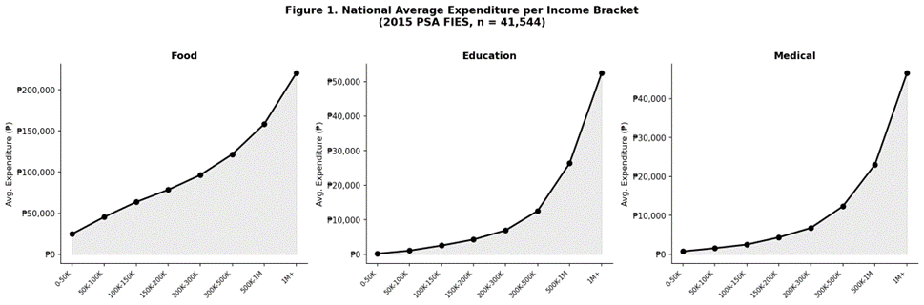
Figure 1. National Average Expenditure per Income Bracket (2015 PSA FIES, n = 41,544)

Analysis
Food expenditure shows a consistently upward but gradually flattening curve, rising from an average of ₱24,768 at the 0-50K bracket to ₱220,224 at the 1M+ bracket. The curve flattens as income increases, which visually previews the declining rate of change that the Central Difference Formula will confirm numerically. This pattern is consistent with Engel's Law, which states that as income rises, the proportion spent on food decreases.
Education expenditure displays a steeper, accelerating shape, nearly flat at lower income brackets (₱185 at 0–50K) before rising sharply at the upper brackets (₱52,473 at 1M+). This steep growth at higher income levels is a visual indicator that education is an income-elastic expenditure: households spend proportionally more on it as they become wealthier.
Medical Care expenditure follows a similar accelerating pattern to education but at lower absolute values, growing from ₱763 at the lowest bracket to ₱46,581 at the highest. The curve is notably steeper in the middle income brackets (100K–300K), which the Central Difference Formula analysis will later identify as the bracket where the rate of medical spending peaks.

4.3 Figure 2 - Rate of Expenditure Change per Income Bracket
Figure 2 shows the graphical presentation of the results after applying the Central Difference Formula to the national level data. Every bar represents the rate of increase in the expenditure of a certain income category, where the rate shows how many more expenditures are made in a particular category for each additional peso earned.

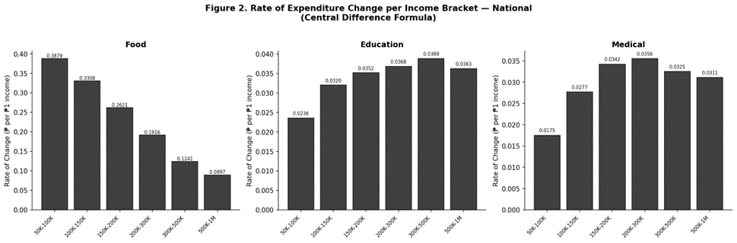
Figure 2. Rate of Expenditure Change per Income Bracket — National (Central Difference Formula)

Analysis
Food: It is evident from the above graph that there is a clear trend of decrease in the value of the bars from left to right, from ₱0.3879 in the case of the category 50K-100K to ₱0.0897 in the case of the category 500K-1M. This implies that for every additional ₱0.39 spent on food, there will be an addition of ₱0.39 by the household earning between ₱50,000 and ₱100,000, while for an additional ₱0.09 spent on food, there will be an addition of ₱0.09 by the household earning above ₱500,000 per month.
Education: Unlike food, the education bars show a rising trend, reaching its maximum in the 300K-500K income class (₱0.0389 per ₱1 of income). From this trend, one could infer that individuals within the middle and upper-middle income classes are highly sensitive to education expenses since their increased income in this income class is associated with higher increases in their education expenses. This income class might indicate the point where the family shifts from free public school education to costly private schools.
Medical Care: The medical care bars rise then plateau, where the peak is achieved between the 200K-300K income range (₱0.0356 for each ₱1 of income), and thereafter falls slightly. Such a trend reflects an instance of expenditure saturation, where individuals do not invest more money on medical expenses with each extra unit of income earned above a particular income level, since basic medical necessities have been met.

4.4 Figure 3 - Cumulative Expenditure Burden Heatmap
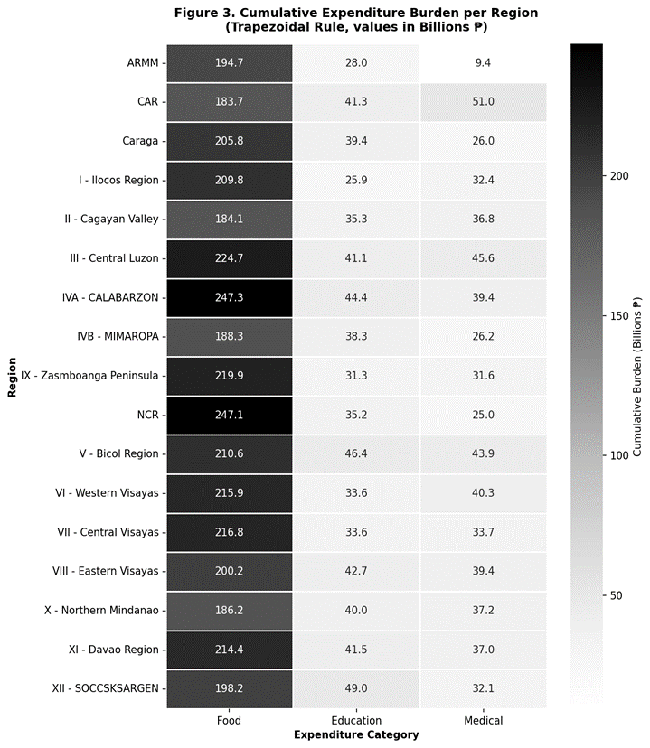
Figure 3 presents a heatmap of the cumulative expenditure burden computed by the Trapezoidal Rule for all 17 Philippine regions across the three expenditure categories. Values are expressed in Billions of Pesos (₱B). Darker cells indicate higher cumulative burden. This visualization allows simultaneous comparison of all 51 region–category combinations in a single
view.

Figure 3. Cumulative Expenditure Burden per Region - Trapezoidal Rule (₱ Billions)
Analysis
Food column: The cells having the lowest level of darkness pertain to IVA - CALABARZON (₱247.26B) and NCR (₱247.09B), which have considerably lower dark tones compared to other cells. It is observed that these two areas have the most significant number of high-income households in the set of data, resulting in the highest total expenditure on food among various incomes. On the other hand, CAR (₱183.66B) and II - Cagayan Valley (₱184.10B) are characterized by the brightest cells in the column of food.
Education column: XII - SOCCSKSARGEN becomes the biggest expense for the region in this column at the amount of ₱48.96 billion. The amount should be taken into account in connection with the relatively low average income of the region. It means that too much money is spent on education for such an average income level, which deserves further attention on how accessible education is here. V - Bicol Region (₱46.37 billion) comes second with similar data.
Medical column: CAThe Cordillera Administrative Region (CAR) represents the highest amount spent on medical expenses, at ₱51.03B, making it the standout outlier (darkest-colored cell) on the heatmap despite having the lowest total amount spent on food among all the other regions. This intraregional variation suggests that families from the CAR spend more on medical expenses, possibly due to issues like remoteness, lack of healthcare facilities, or a higher percentage of senior citizens.
Davao Region (XI): Consistently placed at the middle range for all three sectors—Food (₱214.37B), Education (₱41.48B), and Medical (₱37.00B)—the Davao Region shows a balanced spending pattern in relation to its income levels, without any outlier in any of the mentioned

4.5 Figure 4 - Regional Food Burden Ranking
Figure 4 shows all 17 regions listed in order of their cumulative burden of food expenses. Figure 4 shows a graph with horizontal bars where food—the greatest expense category—is used to provide a ranked overview of the financial burden associated with food expenses.

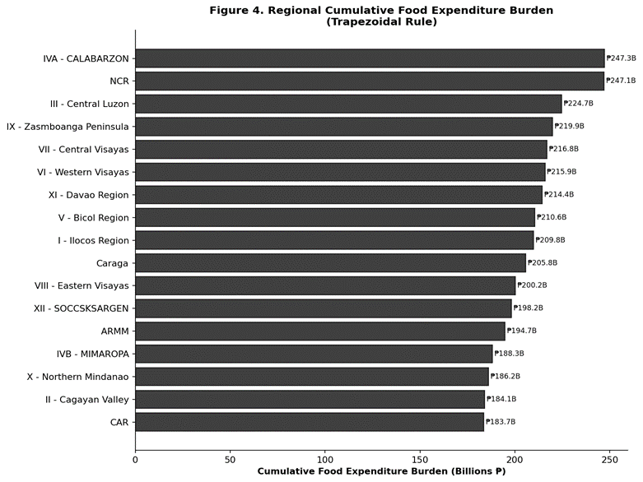
Figure 4. Regional Cumulative Food Expenditure Burden — Ranked (Trapezoidal Rule)

Analysis
There is a difference of ₱63.6 billion from the highest total food burden region (IVA - CALABARZON, ₱247.26 billion) to the lowest total food burden region (CAR, ₱183.66 billion). The wide difference implies a certain degree of regional imbalance in the total household food expenditure, which is caused mainly by differences in the number of people, income, and cost of living in the region.
CALABARZON, NCR, and III—Central Luzon—are the top three areas, and all these are located in Luzon Island, thus having the highest percentage of high-income families in the whole country. The notable food burden recorded in these regions is due to the fact that there is an increase not only in the number of households but also in the absolute spending of these households.
The regions ranked lowly in terms of this ranking include CAR, II-Cagayan Valley, and X-Northern Mindanao, with small urban population sizes and relatively low income levels per household. The effect is to limit the total area covered under their consumption curves, and ultimately, the total burden values incurred.
XI - Davao Region ranks seventh among all the regions in terms of Gross Value, which is ₱214.37 billion, making it part of the upper middle group of the country. This implies that it is a growing economy and its income level is higher than other regions in Mindanao but lower than the first group, which includes Luzon.

4.6 Summary of Visual Findings
The table below consolidates the key quantitative findings drawn from all four figures, serving as a quick reference for the oral presentation and technical report.

Table 6. Summary of Key Findings from Visualization and Analysis
Metric | Result
Food rate-of-change peaks at | 50K–100K bracket (₱0.3879 per ₱1 income increase)
Food rate-of-change is lowest at | 500K–1M bracket (₱0.0897 per ₱1 income increase)
Education rate peaks at | 300K–500K bracket (₱0.0389 per ₱1 income increase)
Medical rate peaks at | 200K–300K bracket (₱0.0356 per ₱1 income increase)
Highest cumulative food burden | IVA – CALABARZON (₱247.26 Billion)
Lowest cumulative food burden | CAR (₱183.66 Billion)
Highest cumulative education burden | XII – SOCCSKSARGEN (₱48.96 Billion)
Highest cumulative medical burden | CAR (₱51.03 Billion)
Davao Region (XI) — food burden | ₱214.37 Billion — mid-range nationally
Davao Region (XI) — education burden | ₱41.48 Billion
Davao Region (XI) — medical burden | ₱37.00 Billion

4.7 Conclusion of Visual Analysis
Collectively, these four charts prove that the numerical approaches used in the present study have been successful at identifying important patterns in the FIES data that cannot be identified by descriptive statistics alone. The patterns illustrated in these charts reinforce three key observations:

• Food expenditure growth decelerates as income rises, with the highest rate of change lies within the lowest income levels, which implies that food expenses are particularly income-sensitive for poorer people.
• Education and medical spending are income-elastic, with their rates of change highest in the middle-to-upper portions of the income distribution, which means that households in higher income brackets are primarily responsible for the rise in expenditure.
• Regional disparities are substantial and category-specific: CALABARZON and NCR have the most expenditures for food, while SOCCSKSARGEN is at the forefront in terms of education expenses, and CAR ranks high in medical expenses. These data show specific spending trends that cannot be explained by average income figures alone.
These findings provide a computationally grounded basis for targeted policy recommendations, and demonstrate the value of applying numerical methods from Computational Science to real-world socioeconomic data.

References
Philippine Statistics Authority. (2015). Family Income and Expenditure Survey (FIES) 2015. Quezon City, Philippines: PSA.
McKinney, W. (2010). Data Structures for Statistical Computing in Python. Proceedings of the 9th Python in Science Conference, 51-56.
Virtanen, P., et al. (2020). SciPy 1.0: Fundamental Algorithms for Scientific Computing in Python. Nature Methods, 17, 261-272.
Hunter, J. D. (2007). Matplotlib: A 2D Graphics Environment. Computing in Science & Engineering, 9(3), 90-95.
Waskom, M. L. (2021). Seaborn: Statistical Data Visualization. Journal of Open Source Software, 6(60), 3021.

